**Year 8 Science**

# **Biology**

# **Heart Dissection**

The heart is the centre of the circulatory system which acts to pump blood to areas of the body where oxygen is needing to be delivered. For this investigation you will be looking at a sheep’s heart and identifying the structures.

**Materials**

In this investigation you will have access to

- Scalpel

- Tweezers

- Blunt probe

- Disposable gloves

- Sheep heart

**Procedure**

1. Place the heart on the dissecting board

2. Observe the outside features of the heart by looking at the image below.

3. Use the blunt probe to investigate which chamber of the heart the blood vessels enter or leave.

4. Use the scalpel to make cut 1 (see image below)

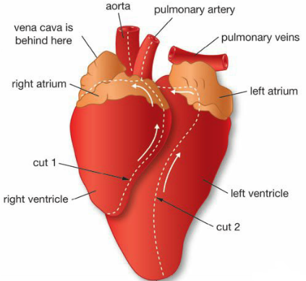

5. Observe the thickness of the right ventricle and open this out

6. Observe the tensons (thread like structures) and the valves (flaps of tissue) to which they are attached

7. Work out how the valves work to control blood flow

8. Observe the flaps of skin at the base of the pulmonary artery. These are semilunar valves.

9. Make cut 2 to open up the left ventricle continue to cut up the aorta (see image above)

10. Observe the thickness of the wall of the left ventricle

11. Find the position of the semilunar valves at the end of the aorta

12. Just above the semilunar valves you should be able to find two small openings from the aorta. These are the branches of the coronary arteries. Use the probe to find out where they go.

**Post dissection questions**

1. Compare the thickness and texture of the aorta and vena cava (2 marks)

_______________________________________________________________________________________________

_______________________________________________________________________________________________

_______________________________________________________________________________________________

2. The superior and inferior vena cava enter into what chamber of the heart? (1 mark)

_______________________________________________________________________________________________

_______________________________________________________________________________________________

3. a) Compare the thickness of the walls of the right and left ventricles (2 marks)

_______________________________________________________________________________________________

_______________________________________________________________________________________________

b) Propose a reason for the differences in thicknesses (2 marks)

_______________________________________________________________________________________________

_______________________________________________________________________________________________

4. What is the function of the valves found in the heart? (2 marks)

_______________________________________________________________________________________________

_______________________________________________________________________________________________

_______________________________________________________________________________________________

5. Follow the flow of blood through the heart (5 marks)

Body tissues 🡺 superior and inferior vena cava 🡺 ___________________ _________________ 🡺 ____________ __________________ 🡺 _______________ 🡺 lungs 🡺 pulmonary veins 🡺 _______________ _______________ 🡺 ________________ ____________________ 🡺 aorta 🡺 body tissues